# DEPARTMENT OF

**ELECTRONICS AND COMMUNICATION ENGINEERING**

# College of Engineering and Technology, SRMIST MINI PROJECT REPORT

**ODD Semester, 2022-2023**

**Lab code & Name :**  Microprocessor, Microcontroller and

Interfacing Techniques (18ECC203J)

**YEAR & Semester :** 3rd YEAR / 5th SEM

**Project Title : Joystick Controlled Servo Motor Using Arduino**

**Lab Supervisor :**  Dr. R. Manohari

**Team Members**

: 1. Ganni Likhit (RA2011004010048)

2. Kunal Keshan (RA2011004010051)

3. Sivaram Chandran (RA201100401004 9)

|  |  |  |  |
| --- | --- | --- | --- |
| Reg. No | RA20110040  10048 | RA20110040 10051 | RA20110040  10049 |
| Mark split up |
| Novelty in the project work  (2 marks) |  |  |  |
| Level of understanding of the design  formula (4 marks) |  |  |  |
| Contribution to the project  (2 Marks) |  |  |  |
| Report writing (2 Marks) |  |  |  |
| **Total (10 Marks)** |  |  |  |

Date:

# Signature of Lab Supervisor

**JOYSTICK CONTROLLED SERVO USING ARDUINO**

# PROJECT DESCRIPTION:

We have built a Joystick controlled servo that is interfaced with an Arduino Uno. Using the joystick, the movement of the servo can be controlled manually in the desired direction.

# OBJECTIVE:

The objective/aim of the project is to build a joystick-controlled servo that connects with an Arduino Uno.

# INTRODUCTION:

# Arduino is an open-source platform used for building electronics projects. Arduino consists of both a physical programmable circuit board (often referred to as a microcontroller) and a piece of software, or IDE (Integrated Development Environment) that runs on your computer, used to write and upload computer code to the physical board.

# Arduino can be used for many applications, in this project, we’re using it to interface the servo motor to the joystick and transfer the joystick controls and movements to be reflected on the servo motor as well.

# WORKING:

# The connections with respect to the Joystick Module are the same i.e. +5V and GND to +5V and GND of Arduino, VRx and VRy to A0 and A1 (Analog Inputs 0 and 1) and the SW pin to Digital Pin 2.

# Coming to the servo motors, their +V (Red) and GND (Brown) wires are connected to +5V and GND (preferably to another 5V Supply with common GND with Arduino). The control wires (Yellow or Orange) of the Servo Motors are connected to Digital I/O Pins 10 and 11.

# Once the code is uploaded to Arduino, it starts reading the data from the joystick and the default position of both the servos is initialized to 90 (in the range of 0-180).

# COMPONENTS:

# Thumb Joystick.

# Arduino UNO.

# Jumper Wires.

# SG90 Micro-Servo Motor.

# Arduino Uno

# 

# Arduino UNO is a microcontroller board based on the ATmega328P. It has 14 digital input/output pins (of which 6 can be used as PWM outputs), 6 analog inputs, a 16 MHz ceramic resonator, a USB connection, a power jack, an ICSP header and a reset button. It contains everything needed to support the microcontroller; simply connect it to a computer with a USB cable or power it with a AC-to-DC adapter or battery to get started. You can tinker with your UNO without worrying too much about doing something wrong, worst case scenario you can replace the chip for a few dollars and start over again.

# Thumb Joystick

# Image result for thumb joystick

# Thumb Joystick is a Grove compatible module which is very similar to the 'analog' joystick on PS2 (PlayStation 2) controllers. The X and Y axes are two ~10k potentiometers which control 2D movement by generating analog signals. The joystick also has a push button that could be used for special applications.

# SG90 Micro-Servo Motor

# 

# A motor rotates from 0 to 180 degrees at each position of 90 degrees so that names it SG90. Servo motors have a gear that reduces the rotational speed of the motor by reducing its RPM and increasing the torque.

# Jumper Wires

# Image result for jumper wires

# Jumper wires are used to connect two points in a circuit. All Electronics stocks jumper wire in a variety of lengths and assortments.

# CIRCUIT DIAGRAM:

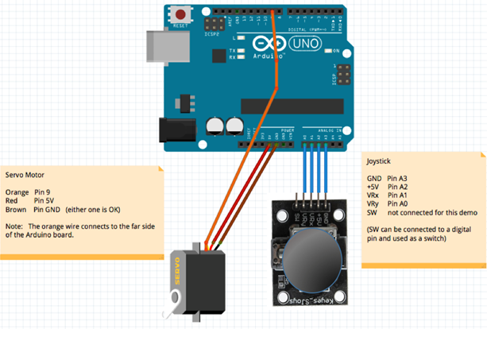

**CODE:**

#include <Servo.h>

#define SERVO_PIN 9

#define GROUND_JOY_PIN A3 //joystick ground pin will connect to Arduino analog pin A3

#define VOUT_JOY_PIN A2 //joystick +5 V pin will connect to Arduino analog pin A2

#define XJOY_PIN A1 //X axis reading from joystick will go into analog pin A1

Servo myservo ;

void setup()

{

Serial.begin(9600);

pinMode(VOUT_JOY_PIN, OUTPUT) ; //pin A3 shall be used as output

pinMode(GROUND_JOY_PIN, OUTPUT) ; //pin A2 shall be used as output

digitalWrite(VOUT_JOY_PIN, HIGH) ; //set pin A3 to high (+5V)

digitalWrite(GROUND_JOY_PIN,LOW) ; //set pin A3 to low (ground)

myservo.attach(9);

}

void loop()

{

delay(200);

int joystickXVal = analogRead(XJOY_PIN) ; //read joystick input on pin A1

Serial.print(joystickXVal); //print the value from A1

Serial.println(" = input from joystick"); //print "=input from joystick" next to the value

Serial.print((joystickXVal+520)/10); //print a from A1 calculated, scaled value

Serial.println(" = output to servo");//print "=output to servo" next to the value

Serial.println() ;

myservo.write((joystickXVal+520)/10); //write the calculated value to the servo

}

# CONCLUSION:

A joystick-controlled servo motor was built using Arduino UNO board. This is a simple project that has wide applications and uses mentioned below:

* Controlling DC Motors and Servo Motors
* Controlling LEDs
* Remote controlled Cars
* Robotic Control

# RESULT:

Thus, a joystick-controlled servo was built using Arduino UNO by programming it and providing the right circuit connections.